**Aim**

To design and deploy a cloud-based Car Booking Reservation System on Zoho Creator to manage car rentals and reservations, thereby demonstrating Software as a Service (SaaS).

**Procedure**

1. **Login to Zoho Creator**
   * Open Zoho Creator and sign in with your Zoho account.
2. **Create a New Application**
   * Click **Create Application → From Scratch**.
   * Name it: **Car Booking Reservation System**.
3. **Design the Reservation Form**
   * Create a form titled **Car Booking Reservation Form**.
   * Add fields for **Customer Details, Car Details, Booking Details, and Payment Information** as listed above.
4. **Create Reports (Views)**
   * Generate a **Booking Report** to display all car reservations.
   * Add filters for **Car Type, Pickup Location, and Booking Date**.
5. **Add Workflow (Optional)**
   * Configure an **email/SMS confirmation** for the customer after booking.
   * Trigger reminders before pickup time.

Car Booking Reservations:

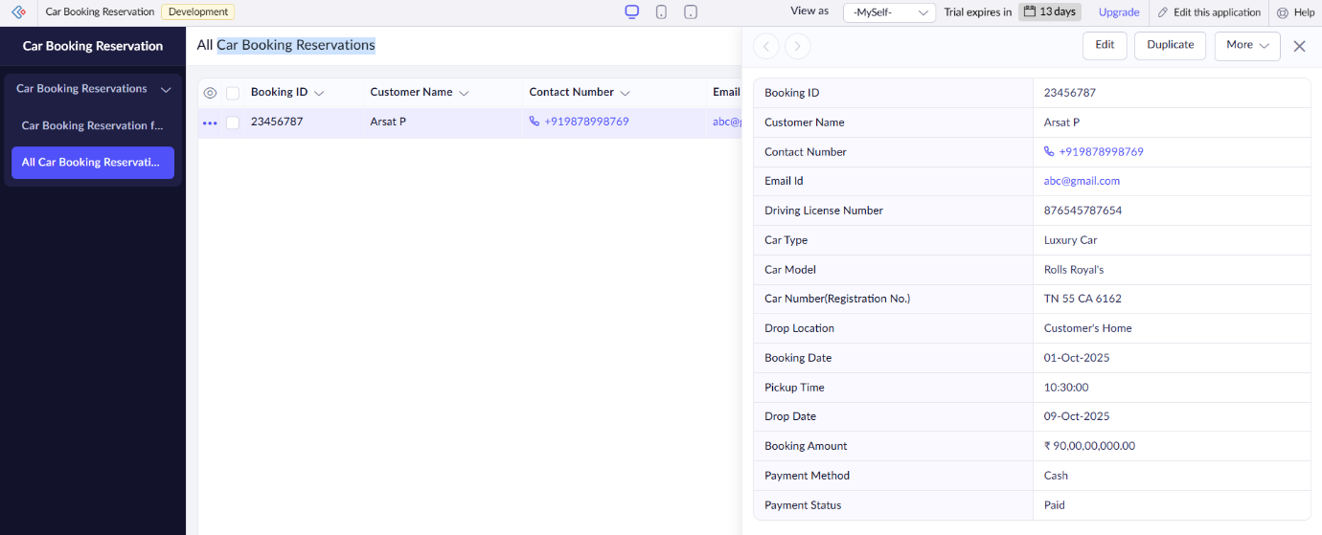

**Result**

* A **Car Booking Reservation System** was successfully created and deployed on Zoho Creator.
* Customers can book cars by providing travel details, pickup/drop locations, and payment information.
* Reports allow easy tracking of reservations, car types, and payment statuses.
* Hosted on Zoho’s cloud, the system demonstrates **Software as a Service (SaaS)** by providing a simple, scalable, and globally accessible car rental platform.